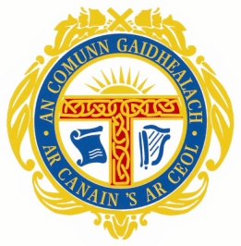

Mòd Ionadail …..

Farpaiseach / Competitor:
Sgoil / School:
Àireamh / Entry Number: Àireamh Farpais / Competition Number:

Gàidhlig

Mark:

MAXIMUM MARKS 100

Beachdan / Comments:

1.

2.

3.

4.

5.

Britheamh / Adjudicator

Ceann Là / Date

